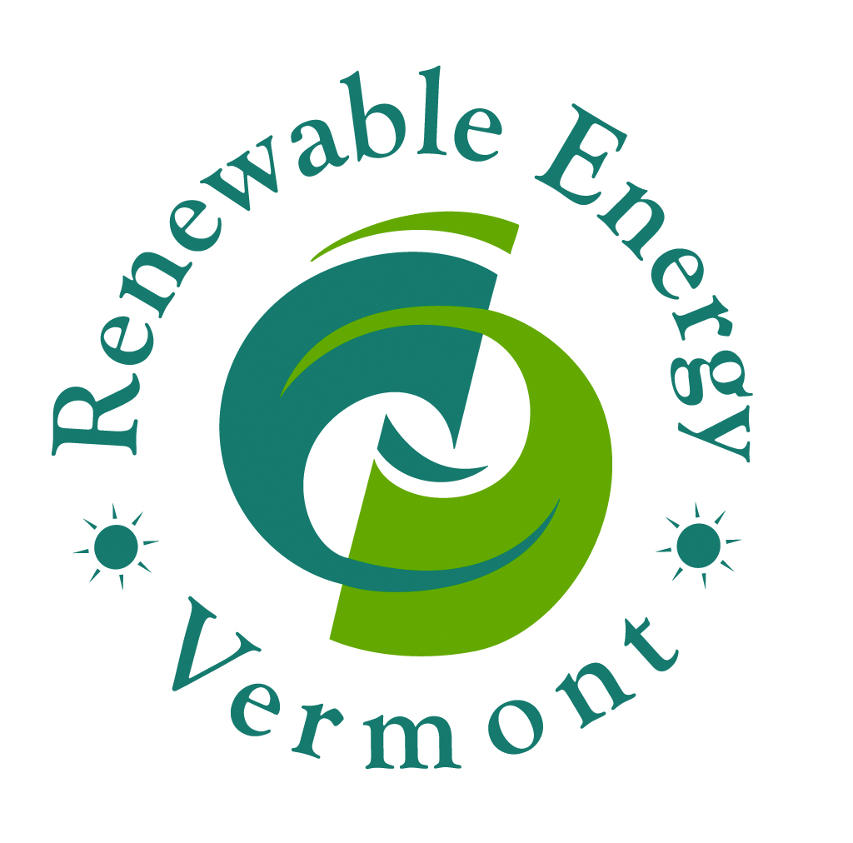
March 18, 2014
Dear Senators,
On behalf of our several hundred business members, thank you for your overwhelming support to expand Vermont’s net metering program last week. The 28-0 vote is reassurance to our growing industry, and our many current and future customers, that our state’s elected leaders are committed to fostering a strong and vibrant clean energy economy. Through that legislation, you have given Vermonters the valuable opportunity to harness their own energy and invest in our state’s energy future. It is the work of this body that has helped Vermont climb to host the most solar jobs per capita in the country.
We are concerned, however, that S.191 now being considered by this body will simply undermine the very work you have just completed. We urge you to oppose S.191, the “solar screening” bill.
S. 191 asks the Senate a fundamental policy question. Currently gas, transmission, nuclear, and all renewable energy are regulated as statewide public goods. Local laws inform the Public Service Board (PSB) process, but they do not have complete control over energy siting. S. 191 changes this policy--but only for solar--to shift governance to the town level. To make matters worse, S. 191 makes this major change using a strait jacket. Unlike other development subject to local control, it allows for no variances for solar.
The PSB's solar track record is solid - siting is changed during the process, based on local input. All solar installation above residential-size (approximately 15kW) are already required to go through a Public Service Board permitting process under Sec. 248, a process which includes the town. What problem is S. 191 trying to solve?
- The proposed legislation singles out solar energy and Vermont’s growing solar industry, ignoring other energy sources, such as natural gas and pipelines.

- The proposal will have a negative impact on the state’s energy goals and solar deployment. We have a statewide planning and permitting process for energy for a reason and this proposal undermines that, allowing towns to effectively zone-out solar.

- The proposal impacts even the smallest of residential solar project, as small as a inhibiting a homeowner’s right to put a single solar panel on their backyard shed.

- The legal implications of this proposal have not been considered thoroughly.

Even while Vermont is #1 in solar jobs per capita, we are far behind other neighboring states such as Massachusetts, Connecticut, and New Jersey in solar deployment per capita. We have a long way to go and Vermonters have repeatedly demanded access to more solar energy. Please help keep us number 1, and don’t block the sun.

Sincerely, Renewable Energy Vermont

